**6.1 Anatomy and Mechanism of Breathing**

Anatomy

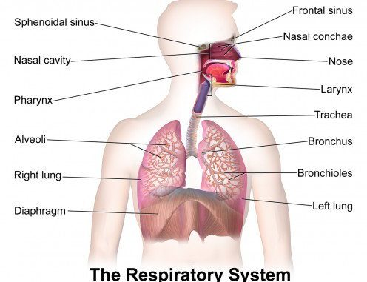

1. External nares of the nose, and nasal cavity
   1. Air is filtered by mucous membrane and nasal hairs (vibrissae)
2. Pharynx
   1. Common pathway for air and food
   2. The opening of larynx (glottis) is covered by the epiglottis during swallowing to guide the food into the esophagus, and out of the respiratory tract
3. Larynx
   1. Only pathway for air
   2. Also contains two vocal cords (maneuvered using skeletal muscles and cartilage)
4. Trachea and Bronchi
   1. Contain ciliated epithelial cells to catch material
5. Bronchioles
   1. Smaller structures of bronchi
6. Alveoli
   1. Terminal surrounded by a network of capillaries → **gas exchange**
   2. Contains surfactant (detergent) that lowers surface tension → prevent self-collapsing

* Lung membranes
  + Imagine your fist (lung) pushing against the balloon (two pleural layers)
  + The intrapleural space contains a thin layer of fluid that lubricates the two pleural layers

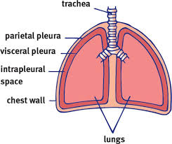

Breathing

* During inspiration, **contraction of diaphragm and external intercostal muscles** is required to create the **negative pressure** in the thoracic cavity (Boyle’s Law)
* Expiration during **calm state** is entirely due to **elastic recoil** of the lungs and the musculature
* Expiration during **more active states** uses **internal intercostal muscles** and **abdominal muscles** to speed up the process

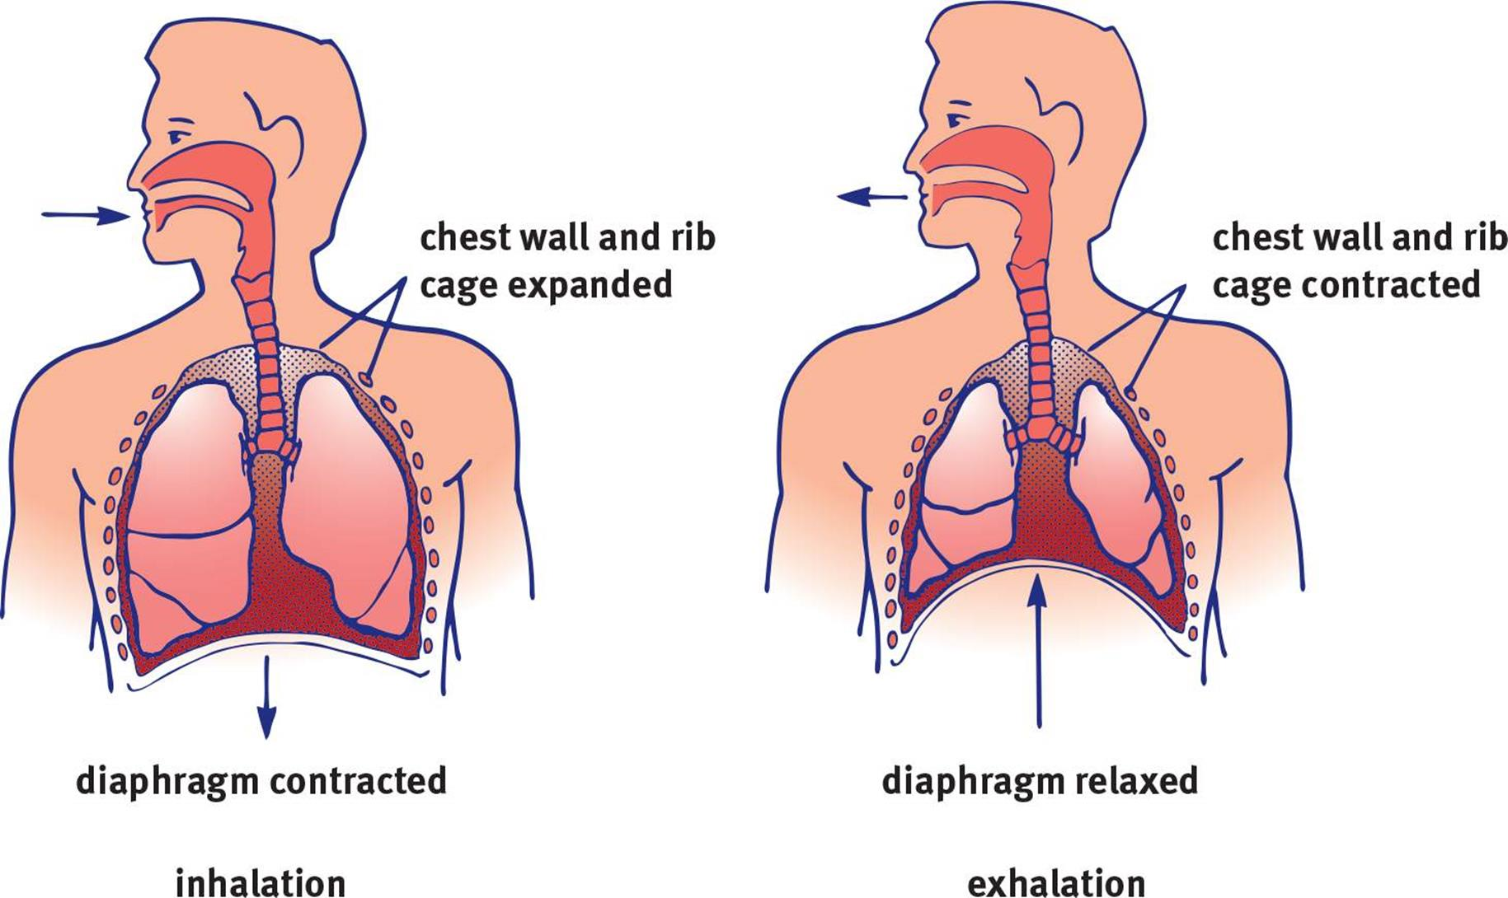

Lung Capacities

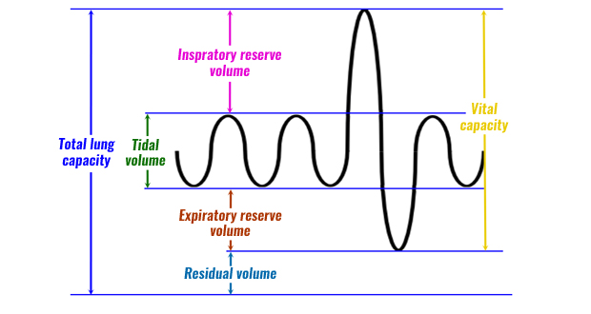

Tested lung volumes (measured using spirometer)

1. Total Lung Capacity (TLC)
   1. The maximum volume of air in the lungs when one inhales completely; usually around 6-7L
2. Residual Volume (RV)
   1. The minimum volume of air in the lungs when one exhales completely; cannot be measured using spirometer
3. Vital Capacity (VC)
   1. The difference between the minimum and maximum volume of air in the lungs (TLC-RV)
4. Expiratory Reserve Volume (ERV)
   1. The volume of additional air that can be forcibly exhaled out after a normal exhalation
5. Inspiratory Reserve Volume (IRV)
   1. The volume of additional air that can be forcibly inhaled after a normal inhalation

Regulation of Breathing

1. Autonomic by medulla oblongata
   1. Has a ventilation centre that fire rhythmically → regular contraction of respiratory muscles
      1. A collection of neurons that contain chemoreceptors that are primarily sensitive to CO2 concentration
   2. Increases respiratory rate during high levels of CO2 blood concentration (hypercarbia or hypercapnia) or low O2 blood concentration (hypoxemia)
2. Conscious control by cerebrum by breathing more quickly or slowly
   1. Will be overridden by medulla oblongata if hypo- or hyper-ventilation happens for too long

**6.2 Functions of the Respiratory System**

Gas Exchange

* Alveoli (one-cell thick to facilitate simple diffusion)
  + O2 diffuses into capillaries → pulmonary vein to the left atrium of heart
  + CO2 (from pulmonary arteries) diffuses into alveoli → expiration

Thermoregulation

* Vasodilation → dissipates heat
* Vasoconstriction → conserves heat
* Evaporation of water in mucous secretions e.g. panting → dissipates heat

Immune Function

1. Nasal cavity
   1. Vibrissae: physical trapping of matters
   2. Lysozyme: breaks down peptidoglycan walls of gram-positive bacteria
2. Internal airways
   1. Mucociliary escalator: propels the mucus, which traps matters, up the respiratory tract to the oral cavity, where it can be expelled or swallowed
3. Lungs (esp. alveoli)
   1. Macrophages: engulf and digest pathogens + signal to the rest of the immune system that there is an invader
   2. IgA antibodies (on mucosal surfaces): protects against pathogens that contact the mucous membranes
   3. Mast cells: have preformed antibodies on their surfaces → releases inflammatory chemicals into the surrounding area when right substances are attached→ immune response

Control of pH

* Bicarbonate buffer system
  + Short-term by lungs
  + Long-term by kidneys
* **Acidemia → more blood H+ → LCP to increase CO2 → increase respiratory rate**
* **Alkalemia → less blood H+ → LCP to decrease CO2 → decrease respiratory rate**

